Body Language in Business –The silent language of influence
Terry Hill: Business Psychologist

What do others really think of you and your proposal, regardless of what they say?
If we know their true thoughts we can change course before its too late…
Here’s 11 things to look out for:

1.The body points where the mind wants to go
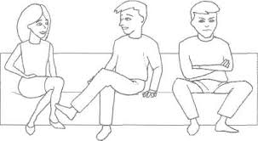
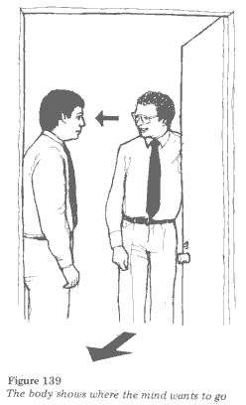

Your prospect emerges from their office just as you are passing. What luck! But whilst they smile and initiate friendly conversation, their body points elsewhere. It’s probably not the time to engage them in serious conversation. They are on a mission and their mind is elsewhere. You should ask for a good time to speak, avoiding a pointless conversation. When they are engaged with you their body turns around to face you. By the same token when two people at a networking event continue to face each other in conversation we should not interrupt.

2.Defensive Barriers
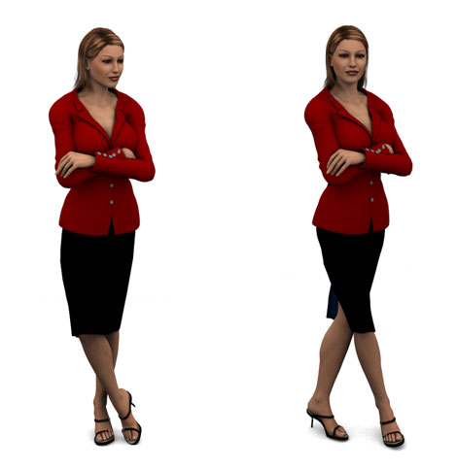
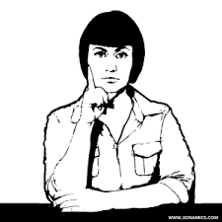
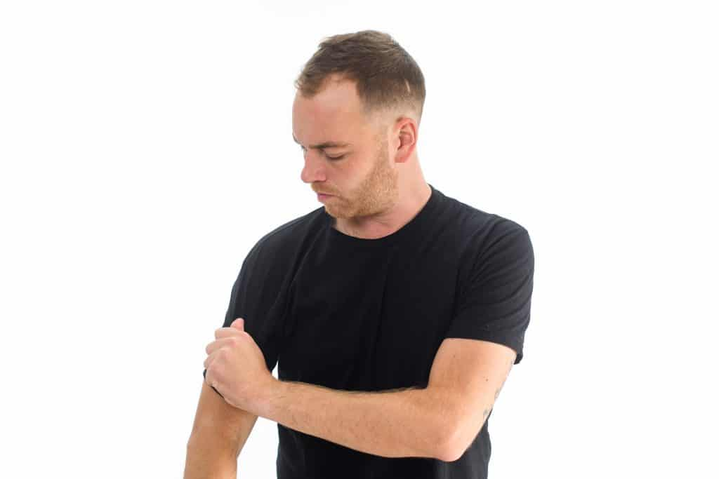

As a child we may have hid behind furniture and mum’s skirt when confronted by scary people entering the room. As adults we do things more subtly. The crossing of arms and legs as you approach suggests discomfort. Are you too tense, or just too close to them for comfort? Hang back, let them choose where they sit, relax and build rapport by identifying something you have in common. You should see the barriers come down as the other becomes more confident and open.

3.Palm Power
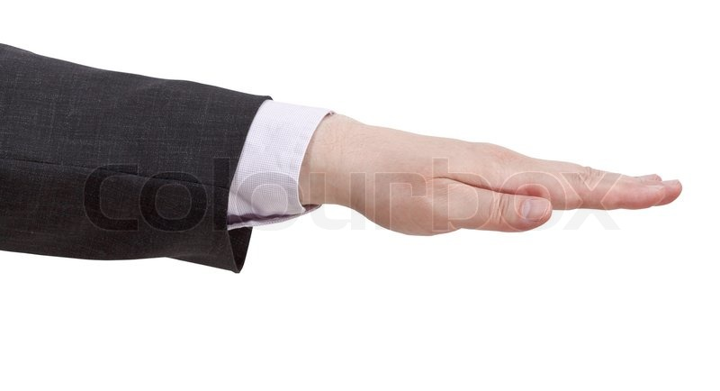

Our ancestors are said to have used open palms when meeting to display honesty, showing no weapons were being carried. Does the other use these when articulating the reasons for their position. Hidden palms should be a warning sign. Children often put hands behind back when telling tales and making requests with hidden agendas.
Palm down gestures are associated with dominance, palm up with submission. Consistent Palm down gestures in your direction suggests the other seeks to control you.
Responding with submissive palms accepts their wishes whilst responding in kind risks conflict. Best to use neutral (vertical) palms and steer the conversation towards an equal partnership.
So which one is best to use when talking on a one to one or making presentations to groups? Well it depends on the situation. When exercising authority use palm down. When inviting open discussion, it’s best to use open palms followed by palm up.

4.That handshake
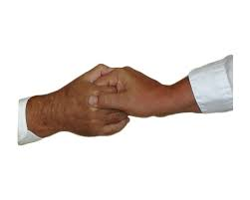

Palm power features in the handshake. Just look at the handshake the managing director offers their staff. Accepting a dominant palm down handshake by keeping your palm upwards might convince the other they can just push you around, whilst trying to overturn it can escalate quickly into a battle of wills. You might try a double-handed shake…if you can get away with it. Otherwise forewarned is forearmed.
A little squeeze to the end of your fingers is the greeting others give when they want minimal involvement with you. Again you will have some rapport building to do before you make that proposal. Listen first. Get them to tell you what’s important to them. Once they feel heard they should become more receptive.

5.Hands to mouth
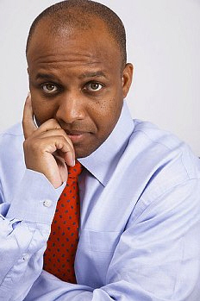

Whenever the hand goes near the mouth during your proposal, you can be pretty sure a negative thought has entered the mind of your prospect or colleague. The further into the mouth the hand, then the more worried they are. The other might continue to say yes but their body language suggests otherwise. Don’t be surprised when they don’t follow through on their commitments. Ask them if they have any questions for you so they can be reassured. Hands covering the mouth even momentarily can be a give away for lies. It’s as though they are trying to stop the deceitful words coming out.

6.Other hand gestures
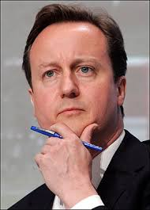

Chin stroking suggests decision-making. Give the users some space. You can usually see how the decision has gone by the gestures they adopt afterwards. E.g. Negative barriers or positive nods and open palms. Holding the hands together suggests an objection to your proposal. The higher the hands the more negative the attitude. Give them something to hold like a piece of literature. It breaks the gesture and weakens the attitude. You can intervene before the negative decision is articulated by reviewing the key points of your proposal and asking about any questions they might have. You might rescue the situation

7.The business gaze

Where is the client looking during your conversation? Toward your mouth and down the neck is what we do in social situations. Some people have the annoying habit of never getting to the point and prefer endless chitchat. Looking at them between the eyes and around the forehead (the business gaze) is a polite but powerful way of getting them to take you seriously and ensure they get down to business quickly

8.Inflated body size
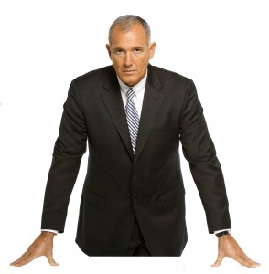

Just like a cat arches its back and a bird fluffs up its feathers, dominant people inflate their body size to threaten and show they are in charge. More subtly they might sit you in a lower seat. Exercise your preference to stand or change the venue if you can.

9.Are we on the same side?
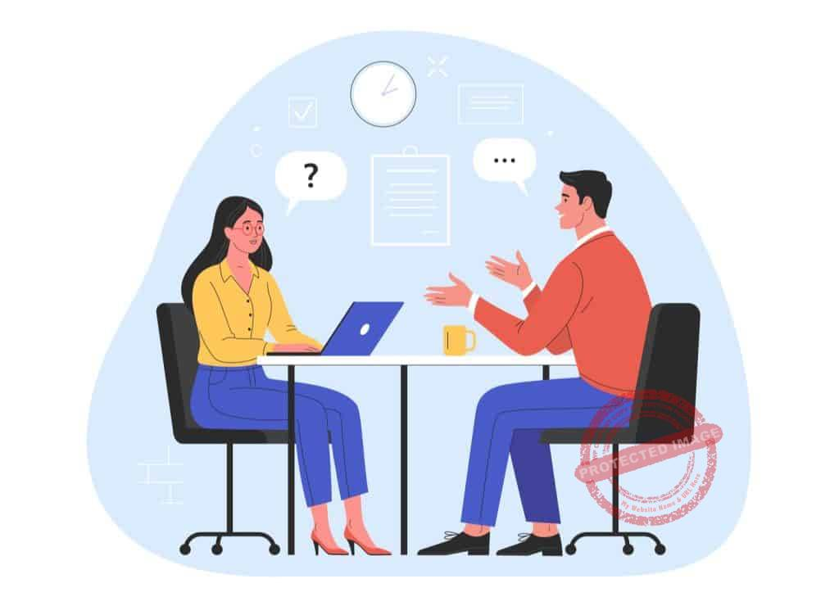
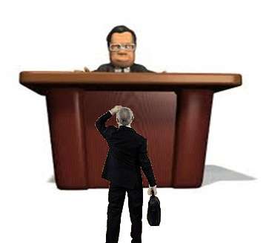

In Bond movies the villain usually sits at the end of a very long table to magnify his status. Speaking across a large desk achieves pretty much the same effect. Its been shown that when we sit opposite another is business, more of the conversation will be negative and we have less chance of reaching agreement. Find a way to move your chair into the corner position at least. Offer a piece of literature for them to read by leaving in the middle of the desk. Once they have taken it into their “territory”, you can offer to come round and better explain the details. You might even end up side-by-side; both feeling you are “on the same page” and maximizing your chances of success

10. “Have I got the deal for you!”

So says the agent as they rub their hands together. Should we be wary?
Well it depends on how fast the hands are rubbed together. The gesture conveys positive anticipation. The speed of rubbing can tell you who that positivity is for. Fast rubbing suggest it’s for you. Slow rubbing suggests it's a good deal for them. Beware!

11. The social mirror
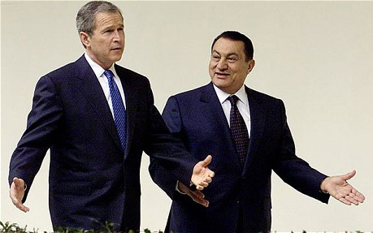
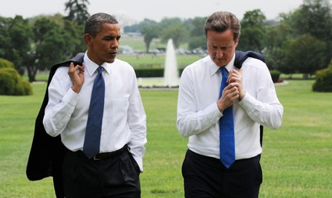

Take a look around the foyer of hotels where business people meet with their colleagues. Often you will see their bodies looking like mirror images of each other in the way they sit and how they gesture. What one does the other soon follows. Such “matching and mirroring” happens very naturally when you are in rapport with someone. Conversely when we consciously match and mirror others we promote rapport between us. This happens subconsciously so make sure you do this subtly. Is this manipulative? We’ll it's a very natural thing to do when you are with someone, and it promotes good communication and mutual co-operation as both parties start to think like the other, warming to their position. A win-win situation is much more likely – can’t be bad!

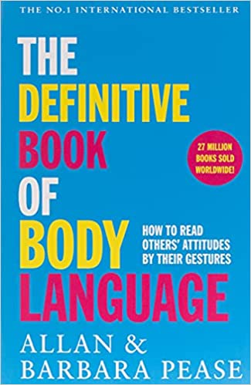
Thanks for reading!

Here’s the text I recommend should you wish to read more

